13 February 2026 PRESS RELEASE
Round Up of Restaurant Surveillance Reveals Shocking Results
We need a radical overhaul of food safety penalties in Fiji. This call comes following a series of joint surveillance operations by the Consumer Council of Fiji, that uncovered "appalling and hazardous" conditions in kitchens across the Nausori-Nasinu, and Lami areas. Conducted alongside Health Inspectors from the Nausori, Nasinu, and Lami Town Councils over the past week, these inspections revealed a blatant disregard for basic hygiene standards.
Out of the 93 restaurants surveyed so far, all 93 were issued a violation notice for some offence, meaning there were 0 restaurants operating without violations. Many premises had serious cleanliness issues, including greasy equipment, dirty floors, and insanitary food preparation and storage areas. Pest problems were common, with flies, cockroaches, rats, and even cats present around food. There were food safety risks, such as uncovered food, cross-contamination, rotten produce, improper thawing, and food warmers not in use. Several sites also lacked basic facilities and compliance, including hot water, proper ventilation, clean PPE, and valid health or business licences.
Some of the most egregious violations are listed below, accompanied by evidence collected by Consumer Council staff.
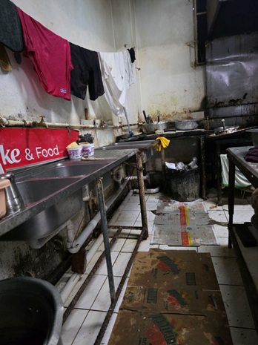 | 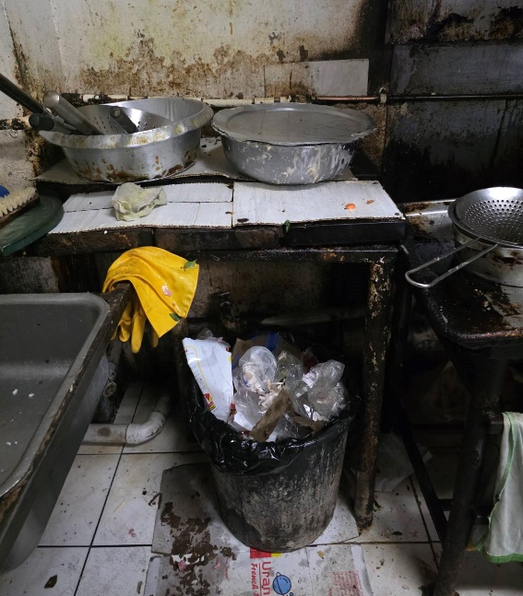
Sweaty personal clothing hung on a makeshift line directly above sinks used for washing food and utensils. Mould and grime on kitchen walls.
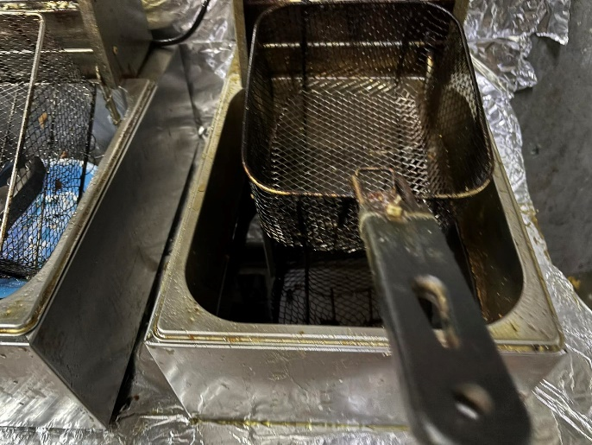 | 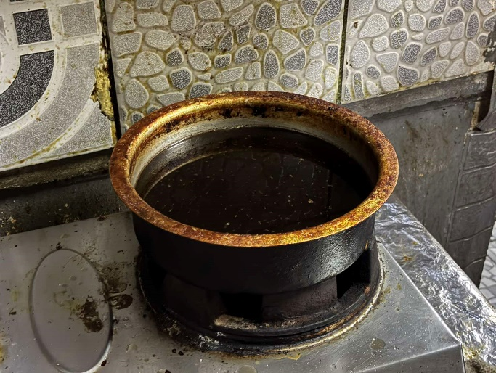
Deeply oxidized, pitch-black cooking oil being re-used in a heavily encrusted pot, posing significant health and carcinogenic risks.
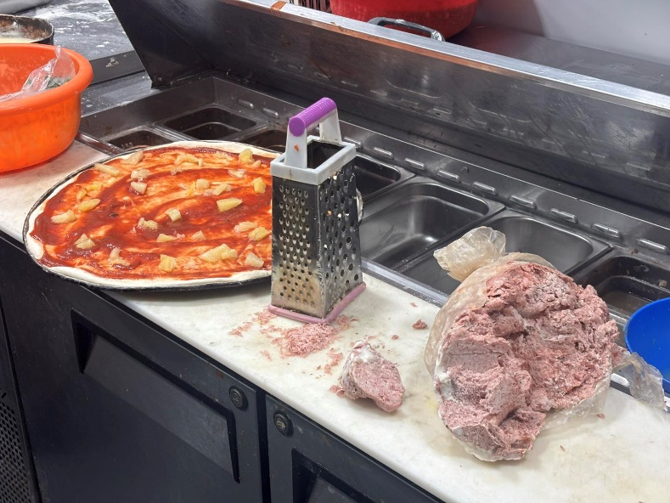
Questionable ground meat, which the restaurant claims to be “chicken mince” is being added as a pizza topping after being grated directly on a prep surface.

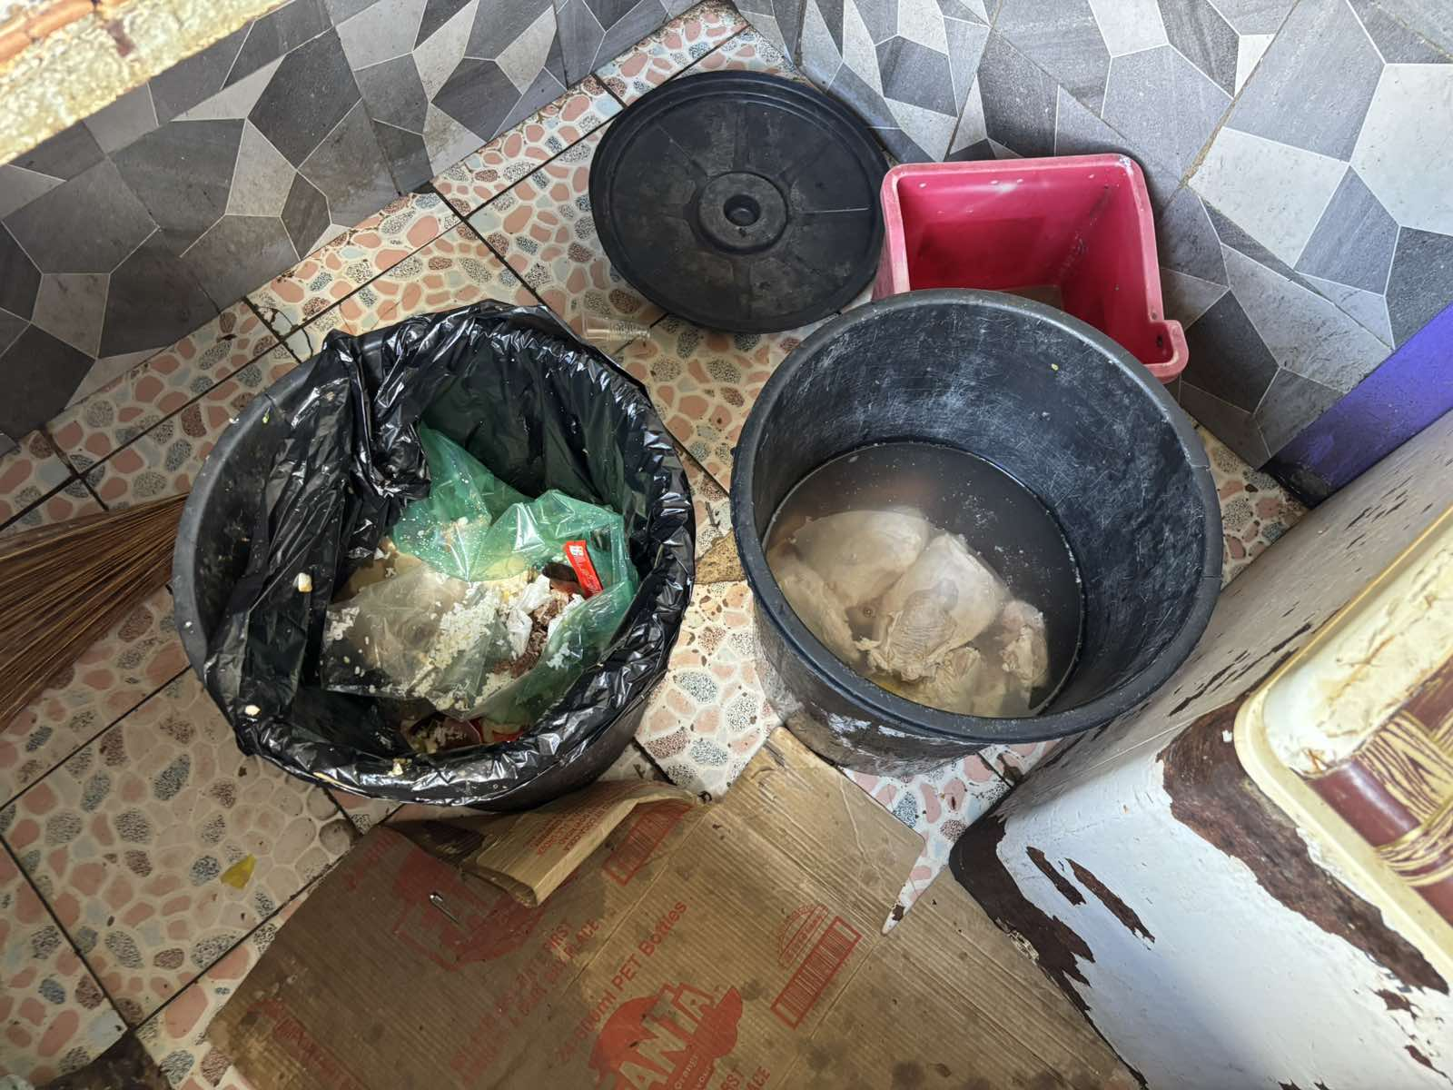 | 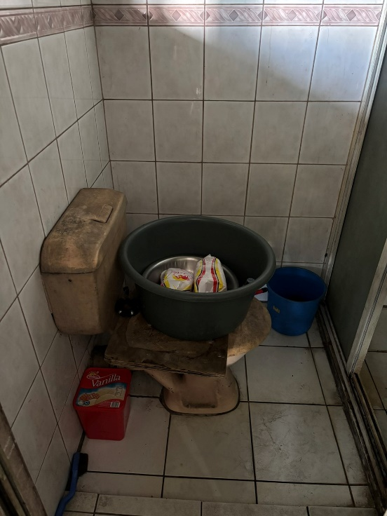
Left: Frozen meat being defrosted in a plastic bin identical to—and placed directly beside—an open bin filled with kitchen refuse. Right: Frozen chicken being defrosted on top of a toilet.
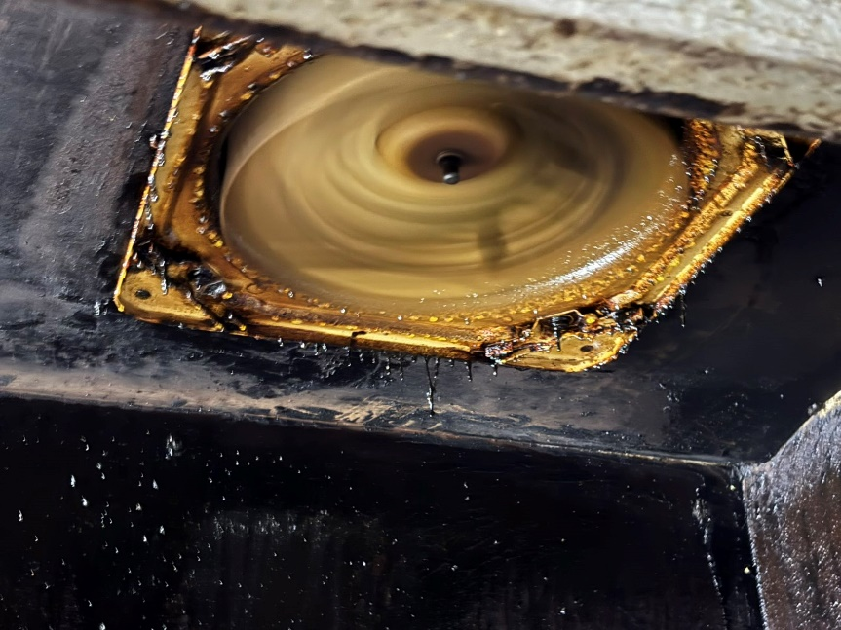
Exhaust fan saturated with layers of old grease, causing liquefied oil to drip back down onto active cooking surfaces and food.
“What we have uncovered in these kitchens, it is a blatant disregard for hygiene standards, and the people who pay to eat there. When a kitchen becomes a laundry room, or black, carcinogenic oil is served as ingredients, the business has failed its most basic moral and legal obligation," says Consumer Council CEO Seema Shandil.
“The current fines are clearly not a deterrent. We are seeing a pattern where traders treat health violations as a minor 'cost of doing business.' This must end. We are calling for the urgent introduction of heavy spot fines and a 'name and shame' policy by municipal Councils and the Ministry of Health. If a restaurant cannot maintain a clean kitchen, they have no right to be in business. We will continue to work with health inspectors, since they have the authority to issue fines and abatement notices, to ensure that these kitchens are either cleaned up or closed down permanently,” added Shandil.
“We also call on consumers to completely boycott unhygienic restaurants. If you see that a restaurant does not maintain cleanliness, and their kitchens are filthy, refuse to eat there, and encourage your friends and family to do the same.”
Consumers who face filthy conditions in restaurants are encouraged to report their complaints to the toll-free National Consumer Helpline 155 or complaints@consumersfiji.org.
-ENDS-
Post Script:
All surveillances were carried out in the company of Health Inspectors, and while the Consumer Council is not in a position to name these restaurants, such information can be sought from the respective municipal councils where these surveillances took place.
-Nasinu Town Council CEO: Felix Magnus
3341242, 9743188
fasmagnus2@gmail.com | felix.magnus@nasinu.com.fj | emareiwai@nasinu.com.fj

-Nausori Town Council CEO: Rajesh Kumar
3477133, 9929115
rajesh.kumar@ncc.com.fj

-Lami Town Council CEO: Azam Khan
3361666, 9144808
azamk4@hotmail.com

