12 February 2026 PRESS RELEASE
More Deterrence Needed Against Kava Adulteration
Consumers continue to raise concerns over the sale of adulterated kava, which is affecting both individual buyers and businesses alike.
This follows the recent warning issued by the Ministry of Agriculture regarding compromised kava quality. The Ministry has highlighted cases where cooking products, including flour, have been mixed with kava, particularly for export, risking Fiji’s reputation in the global market.
Just two weeks ago, the Council received a complaint against a kava dealer in the Suva Municipal Market. The complainant was a small business owner from Beqa who only discovered the issue after having resold the product to his customers. She claimed that the kava was very powdery, and a white sediment settled at the bottom after mixing with water.
Following the complaint, the Council conducted its own investigation, comparing the product with a few other kava samples. Clear differences could be observed in appearance and smell. While the other kava samples that were used as a control, produced a light brown colour consistent with the usual colour of kava, the suspected product was pale and grey, with visible white powder and black specks, indicating it had likely been mixed with another substance.
“This is not an isolated incident. The Council has received numerous complaints in the past, including from including from international consumers, about kava that was dubious in appearance, odor and taste,” said Consumer Council CEO Seema Shandil. “We fully support the Ministry’s call for farmers, traders, and exporters to maintain strict quality standards.”
With consultations on the proposed Kava Bill underway, the Council is calling for stronger enforcement measures, including fines and license blacklisting for those found adulterating kava. “There needs to be a strong set of penalties in place to deter businesses from engaging in these practices. The new legislation must send a clear message that adulteration will not be tolerated,” added Shandil.
Consumers are advised to purchase kava from reputable vendors and report any suspicious products to the Consumer Council via its toll-free National Consumer Helpline 155.

PRODUCT SUSPECTED OF ADULTERATION  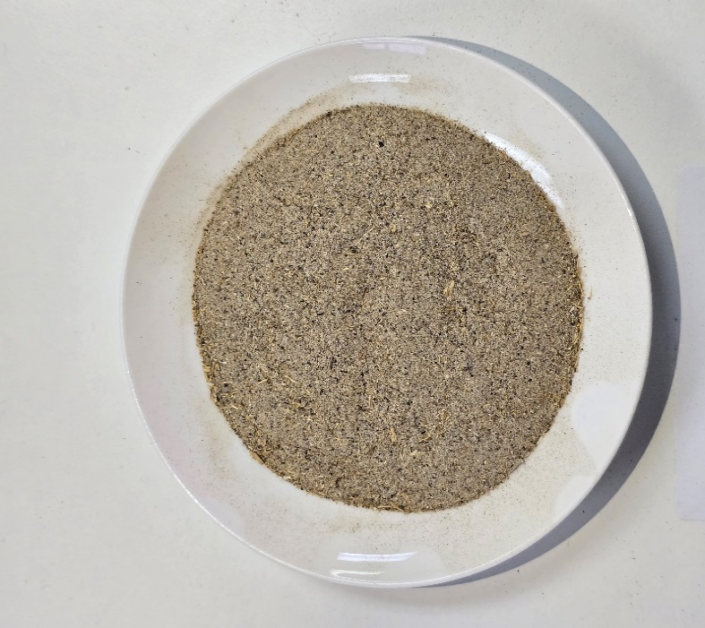 | STANDARD KAVA  